Task 2: API Integration & JSON Handling
Objective: Fetch data from an API, parse JSON responses, implement search/filter logic, and handle errors.
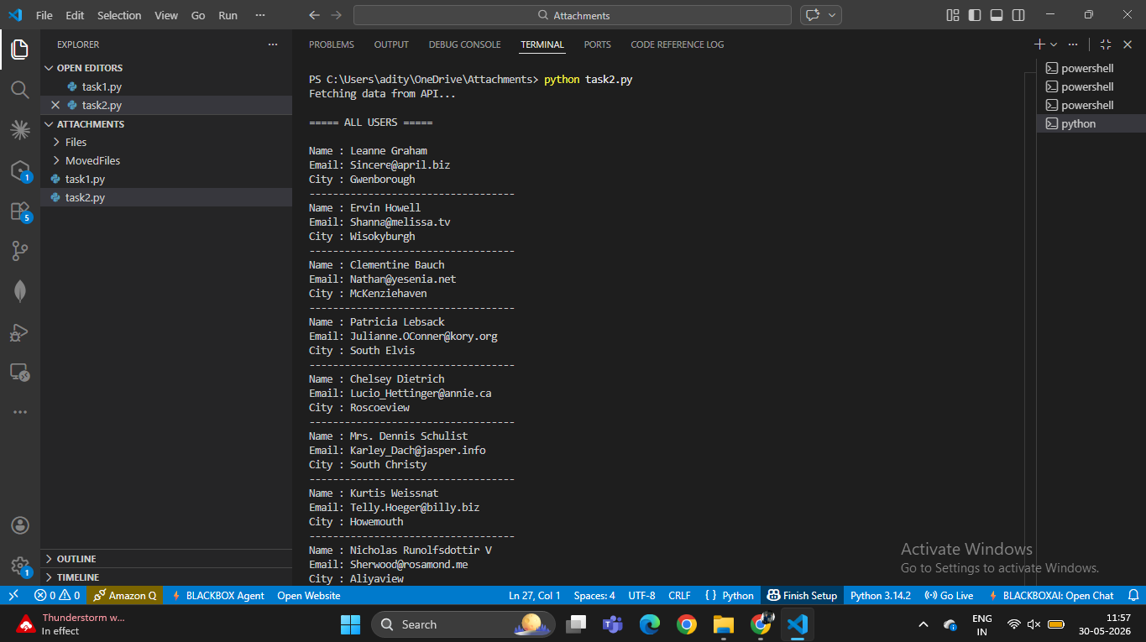
Figure 1: API data successfully fetched and displayed.
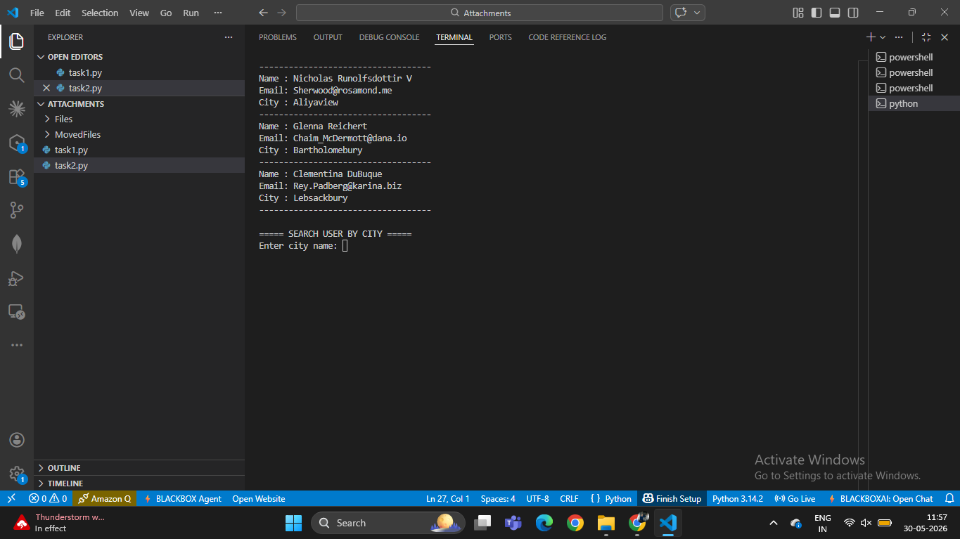
Figure 2: Search feature requesting city input.
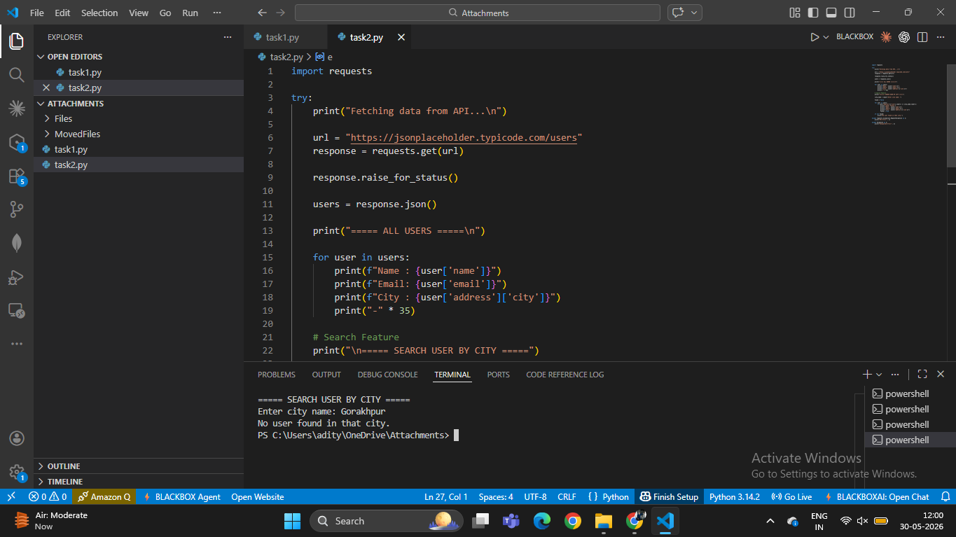
Figure 3: Search with a city not present in the dataset.
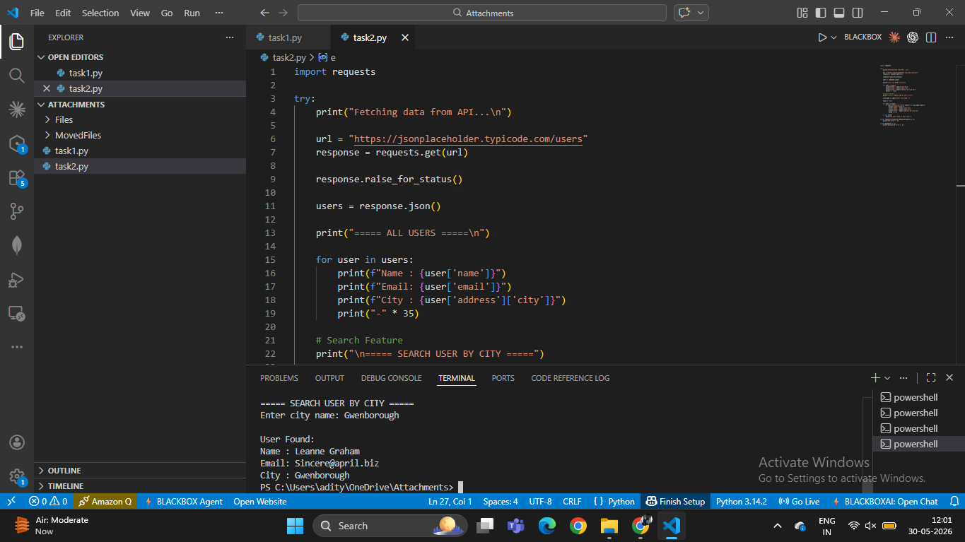
Figure 4: Successful search result for Gwenborough.

Conclusion
The program successfully connected to the API, processed JSON data, displayed user information, and implemented city-based search functionality.

